OpenGD77 Phase 1 User Guide   
(9th September 2019)

Contents

1. Introduction 3

1.1. Download links and other resources 5

2. Installation 6

3. Main screens (VFO and Channel screens) 7

3.1. DMR specific functionality on the VFO and Channel screens 9

3.2. FM specific functionality (VFO and Channel screens) 14

3.3. VFO specific functionality 17

4. Transmitting 20

5. The control keys and buttons 21

6. The Menu System 22

7. Main Menu 23

7.1. Zone 24

7.2. RSSI 27

7.3. Battery 28

7.4. Last Heard 29

7.5. Firmware Info 30

7.6. Utilities 31

7.7. Display Options 32

7.8. Channel Details 33

7.9. Credits 34

8. Making and receiving DMR Private Calls 35

8.1. To make a Private Call 35

8.2. To Receive a Private Call 36

9. Programming Channels and Talkgroups for use with OpenGD77. 38

9.1. OVERVIEW 38

10. USING THE COMMUNITY CPS TO PROGAMME A GD-77 42

New Driver Installation 42

OpenGD77 Menu 42

Backup Before You Do Anything Else! 43

Reading and Writing Your CodePlug 43

Writing DMR ID’s 43

# Introduction

This user guide is a work in progress as is the Open GD77 firmware. If you find any errors or omissions please let me know so they can be corrected.

Due to the rapid pace of development some of photos of screens are now out of date, because the DMR TS and CC are now down shown on all DMR screens.

The photos will be updated when the firmware is not changing so quickly

The intention of the OpenGD77 firmware is to create a new fully featured non-commercial firmware that entirely replaces the Radioddity GD-77’s factory firmware. This firmware is specifically designed for Amateur Radio use, and has features not available in the official firmware.

**Note.   
The firmware is still under development and there are some key areas of functionality which have yet to be written.**

1. Currently the firmware only works on DMR with simplex hotspots or to other DMR radios for simplex contacts. This is because the firmware currently does not fully support DMR Tier 2 required for most commercial and MMDVM repeater systems.   
   However DMR mode can be used with a simplex hotspot and for DMR simplex operation.
2. FM Rx and Tx transmission works.

This includes repeater operation using CTCSS on both Tx and Rx.

1. On DMR, only Talk Group “calls” and Private calls are currently possible

Text messaging and other similar features are currently not supported, but are on the To Do list.

For a full list of current bugs, and proposed enhancements see

<https://github.com/hamdv/opengd77/issues>

**Now onto what’s great about the OpenGD77 firmware…**

The firmware is designed for Amateur Radio use, especially on DMR, and has a number of features for Amateur Radio use which are not normally available on commercial DMR radios.

These include direct numerical entry of DMR TalkGroup numbers and use of the Rx Group list to control the TG’s selectable for each DMR “channel”

Also, as far as possible the firmware is open source. This allows anyone to modify the firmware to suit their own individual needs, and also for peer review and improvement of the firmware source code

**Credits:**

Conceived by Kai DG4KLU, including development of the framework and all the FM and DMR Tx and Rx (Tier 1) functionality.

User Interface, Display driver, Codeplug API, EEPROM memory API, Flash memory API, Hotspot mode and many other features developed by Roger VK3KYY

Additions from Colin G4EML, including FM CTCSS and “All Channels” zone functionality

This user guide: Alister G0NEF and Roger VK3KYY

Thanks to all the Beta Testers that provide detailed bug reports and user feedback, especially VK7ZCR and W1RHS.

## Download links and other resources

**Firmware source code and binaries:**

Stable version:  
 <https://github.com/hamdv/OpenGD77>

Note. The Stable version is currently very out of date and does not include features like Hotspot mode.

Latest experimental version from Roger Clark VK3KYY, with the newest features:  
<https://github.com/rogerclarkmelbourne/OpenGD77/raw/master/firmware_binaries/daily_builds/firmware.sgl>

**GD-77 Community CPS with support for OpenGD77:**

<https://github.com/rogerclarkmelbourne/radioddity_gd-77_cps/raw/master/installer/RadioddityGD77CPS31XCommunityEditionInstaller.exe>

# Installation

The firmware can be installed onto the GD-77 using the firmware update tool provided by Radioddity with their official firmware update packages. This can be downloaded from Radioddity’s website [www.radioddity.com](http://www.radioddity.com) . See Radioddity’s documentation on how to use their firmware update tool.

The OpenGD77 firmware (.sgl file) can be downloaded from Github, using either of the links as listed in section 1.1 of this guide.

Installation of the OpenGD77 firmware is undertaken at the owners own risk, but the official firmware can usually be reloaded onto the GD-77 if the user has problems with the OpenGD77 firmware.

Note. The official Radioddity GD-77 CPS PC software is not compatible with the OpenGD77 firmware, and the “Community CPS” should be used instead. This can be downloaded from the link show in section 1.1 of this guide

# Main screens (VFO and Channel screens)

The OpenGD77 firmware has 2 main screens. The VFO screen and the Channel screen. These are similar to the channel and VFO screens in the official firmware, except have additional functionality.

Initially after the OpenGD77 firmware is installed, the VFO screen will be displayed.

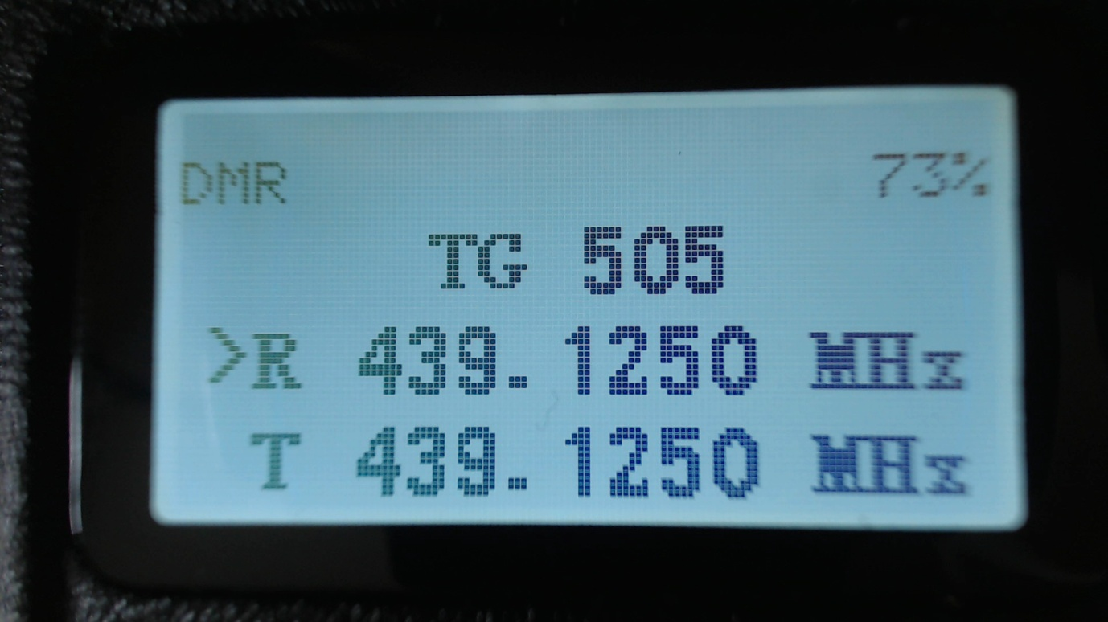

The frequency used in the VFO for both Tx and Rx will be read from the “VFO A” settings of the codeplug.

On both the VFO and Channel screens, the mode (DMR or FM) is shown in the top left of the display, and the battery voltage percentage is shown in the top right of the display

On the VFO screen, the Tx and Rx frequency are shown, as well as the TalkGroup when in DMR mode.

The arrow to the left of the R (receive frequency) indicates that the keypad up and down arrows and number entry keys will control the Rx frequency.

The channel screen displays the same information in the top row, but displays the Channel name (in this example “VK3RGL D”) as well as the Zone (“VK3 DMR”) and in DMR mode the TalkGroup will also be displayed

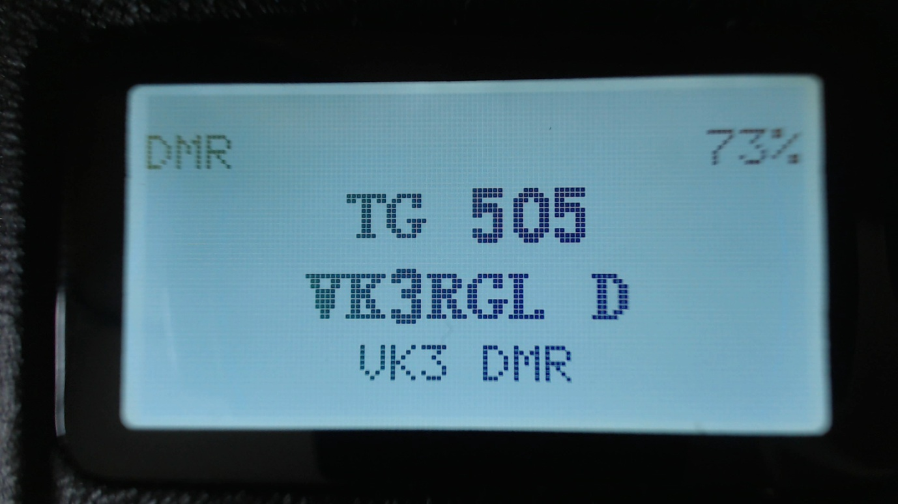

On both the VFO and Channel screens:

Press the **Red** menu button to toggle between the VFO and Channel screens

Press the **Green** menu key to enter the menu system

Pressing **Function + Green** gives quick access to the Channel details screen, which can also be accessed via the menu system.   
Note.   
The VFO is actually a special type of channel; hence the Channel Details screen also works for the VFO.

Press the **Star (*)** key to toggle between FM and DMR mode on either the VFO or Channel screens.

## DMR specific functionality on the VFO and Channel screens

When a DMR signal is received which uses the same Colour Code as selected for the VFO or Channel, the radio display will show the station’s Talkgroup and DMR ID

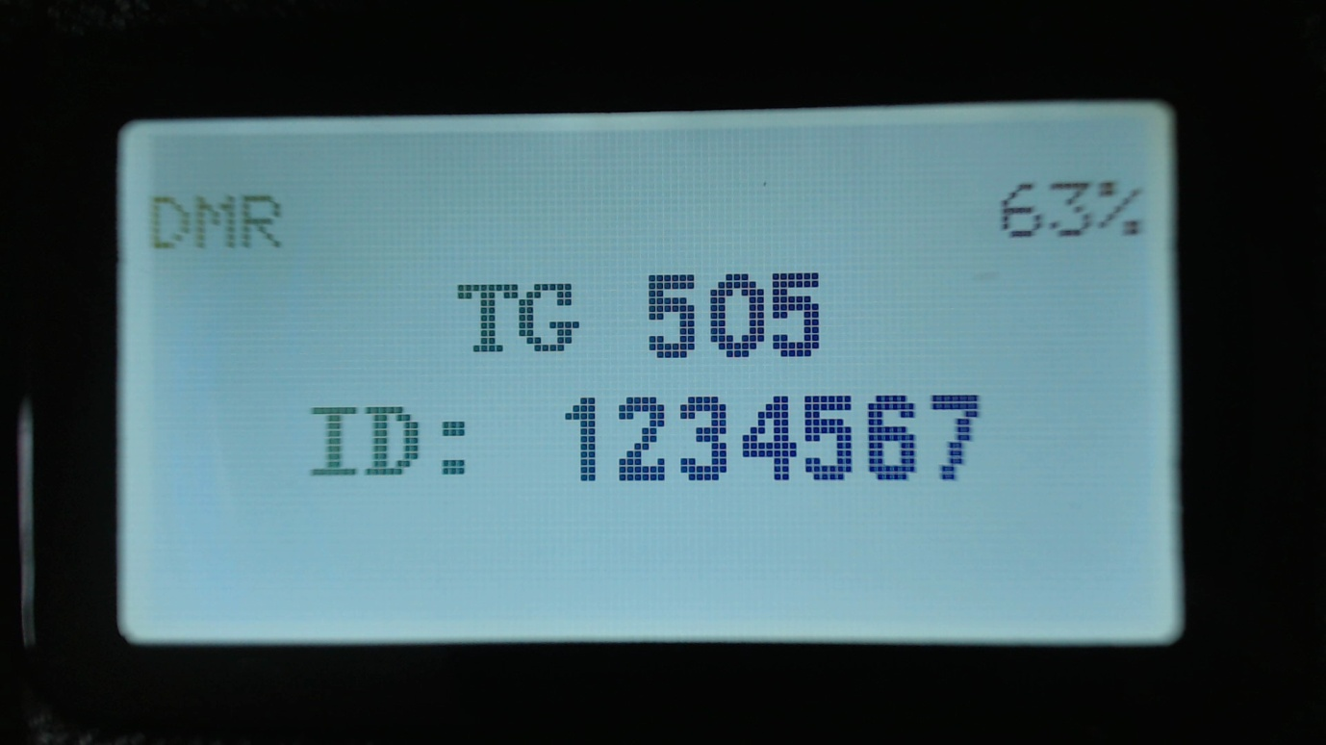

If the DMR ID is in the DMR ID database previously loaded into the radio, the callsign and name will be displayed.

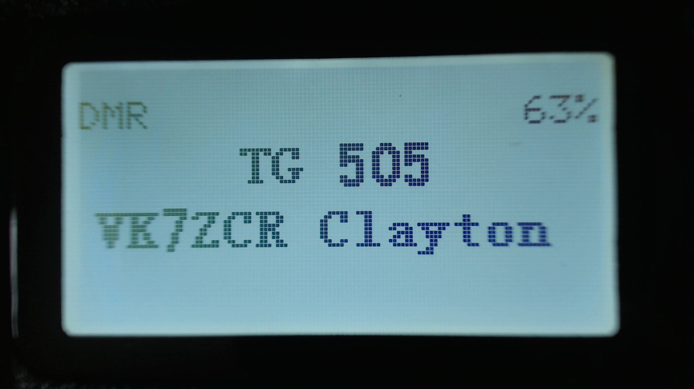

On the Brandmeister network, if the station’s DMR ID is not in the DMR ID database, the display will show the information sent by Brandmeister in the “Talker Alias” data

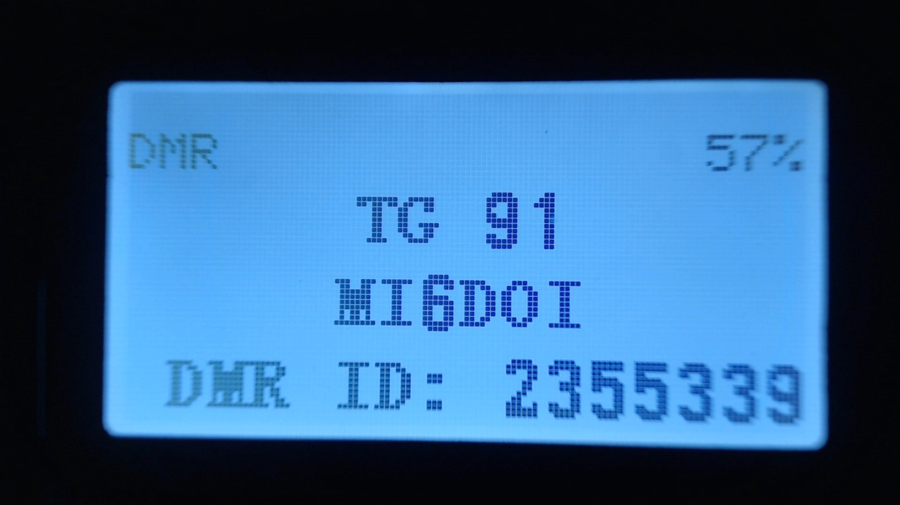

The callsign will be displayed in the centre of the screen, and additional information will be displayed at the bottom of the screen. The additional information will default to the text “DMR ID:” followed by the stations DMR ID number.

If the station has entered any data into the APRS section of their Brandmeister “Self care” page, that text will be display in place of the DMR ID number.

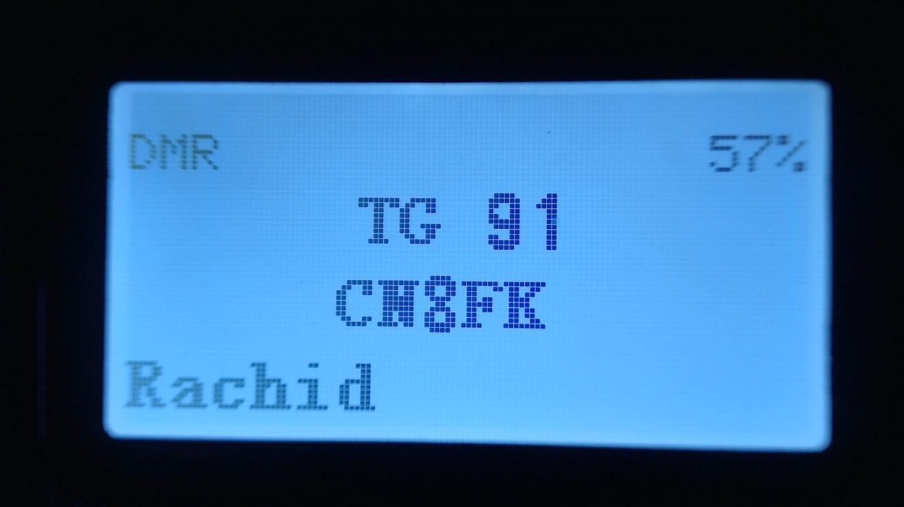

Note. As the Talker Alias data is sent slowly as it is embedded inside the DMR audio data frames, the callsign will appear first and about half a second later the DMR ID or other text will arrive via the DMR data and be displayed.

Press the **Left** or **Right Arrow** keys to cycle through the TalkGroups in the RxGroup assigned to the VFO or Channel in the CPS.

Press the **Hash (#)** button to enter the TalkGroup number. Followed by the Green key to confirm

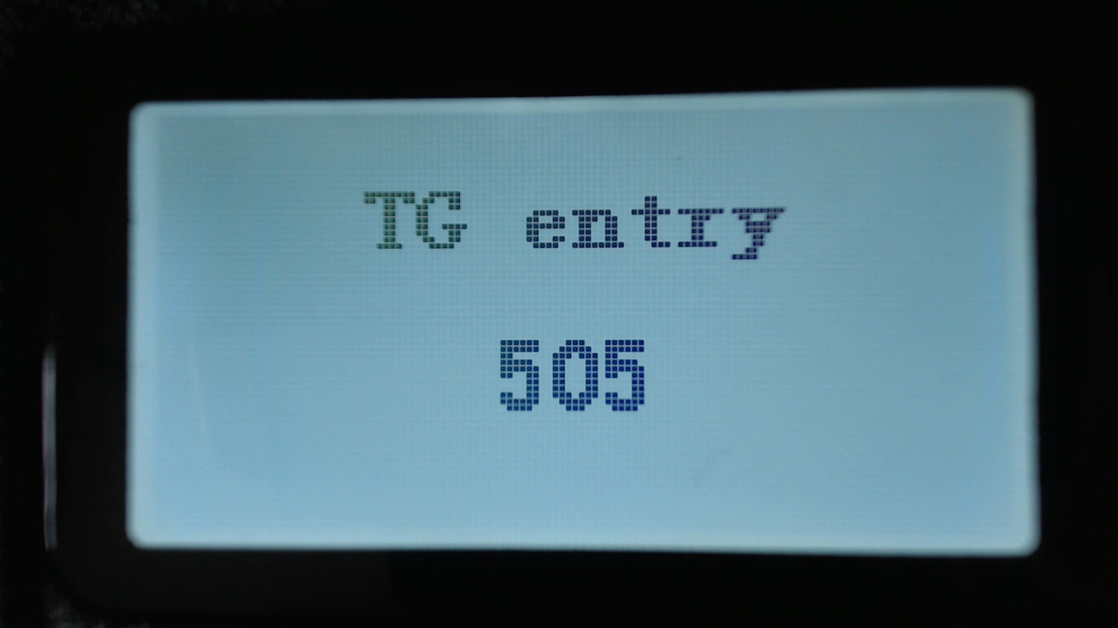

Press the **Hash (#)** again to enter a Private Call DMR ID number.

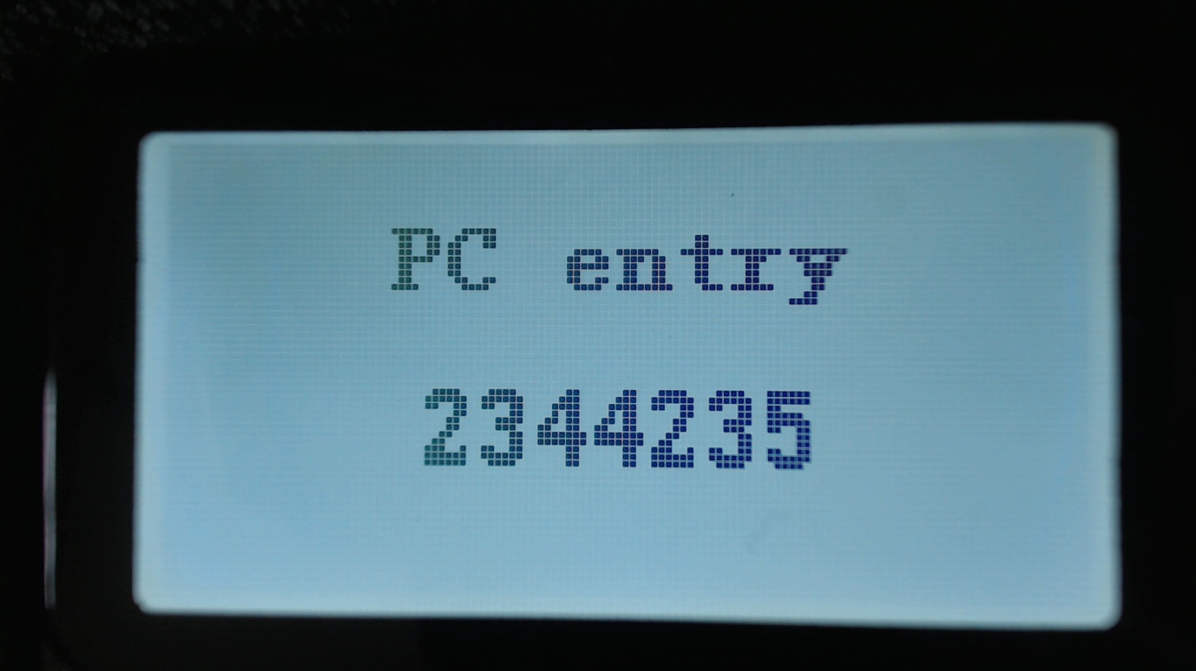

In all numeric entry screens, pressing the Red menu key exits back to the previous screen, either the VFO or Channel screen

Additionally  
In Private Call entry mode, and the **Function + Hash (#)** key is pressed, an alternative DMR ID can be entered, for test purposes, to temporarily override your normal DMR ID number which was loaded from the codeplug.

This DMR ID will be used for transmission until the radio is rebooted or you enter your own DMR ID via the same screen.

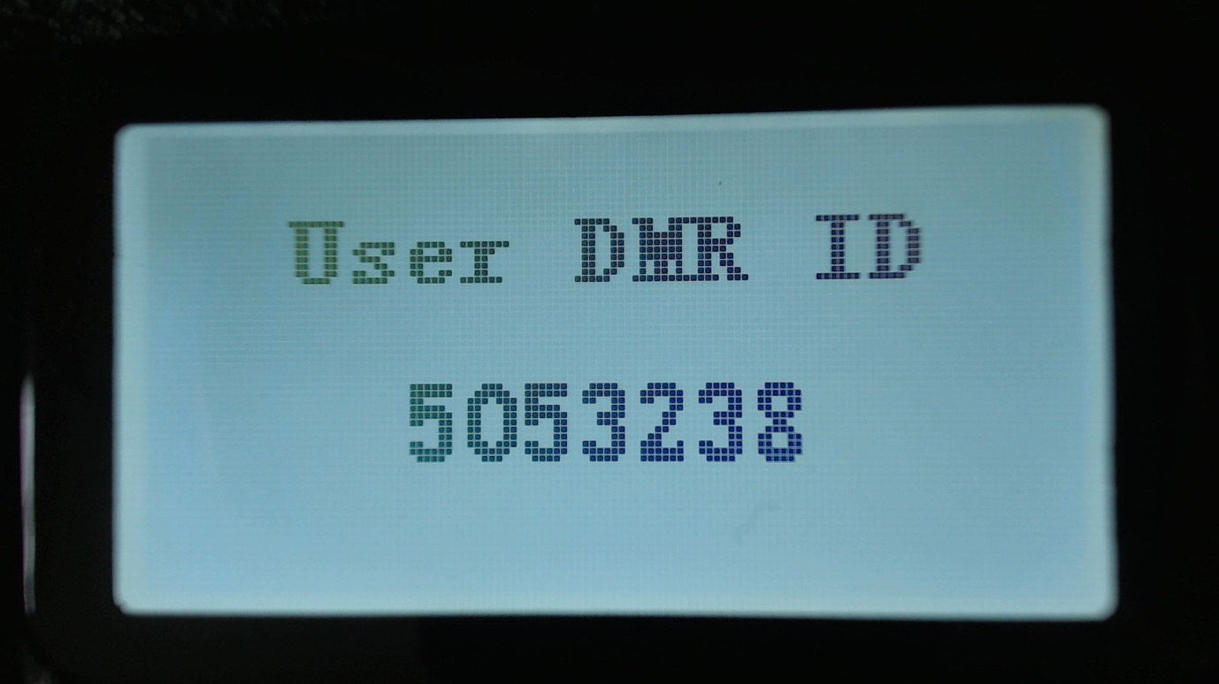

## FM specific functionality (VFO and Channel screens)

In FM mode and a CTCSS tone is set for the channel or VFO, the letters CT CR or CTR will be displayed next to the FM indication at the top of the screen.

CT means CTCSS Tx tone only

CR means CTCSS Rx tone only

CTR means CTCSS Tx and Rx tones.

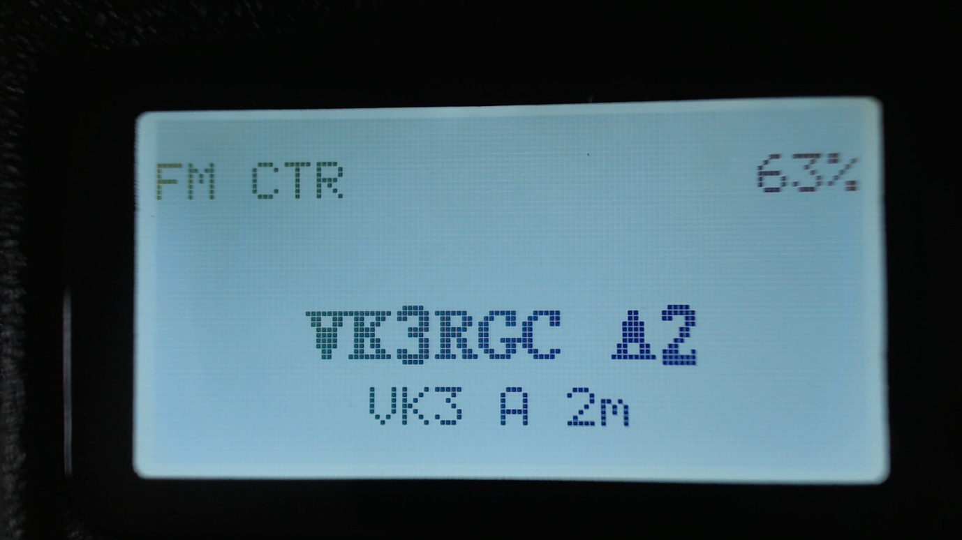

Pressing **Function + Left** or **Function + Right** keys, activates the FM squelch control

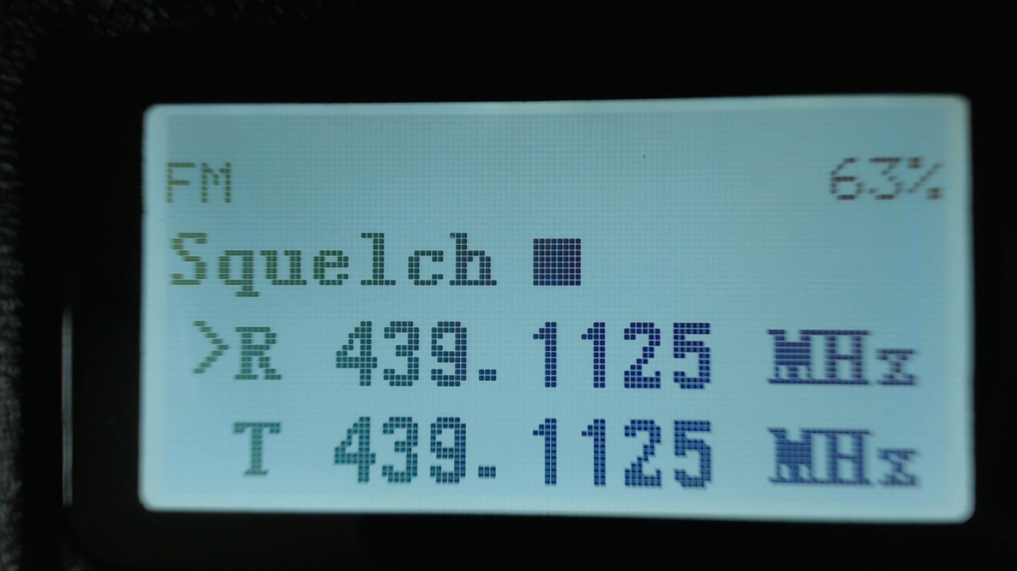

Once in squelch control mode, pressing **Right** or **Function + Right** closes the squelch more, **Left** or **Function + Left** opens the squelch more.

The VFO and each channel have individual squelch settings

The variable squelch can be set to different values for each Channel and for the VFO using a new feature in the Community CPS, where the squelch can be set anywhere between Open and Closed in 5% steps.

In this example the squelch in the VFO is set to 20%



Note.

If the squelch is changed in the VFO the value will be remembered even if the radio is power cycled.

However if the squelch on a channel is changed, the value is only a temporary override.

## VFO specific functionality



The VFO displays both the Tx and Rx frequency at all times.

When the currently selected frequency is the **Rx** frequency, an arrow is displayed to the left of the “**R**”, changes to the frequency will adjust both the Tx and Rx frequencies.

Pressing the **Up** or **Down** **arrows**, will change frequency by the value defined in the frequency Step value defined for the VFO in the CPS.

Pressing any of the number keys allows the direct entry of the frequency.

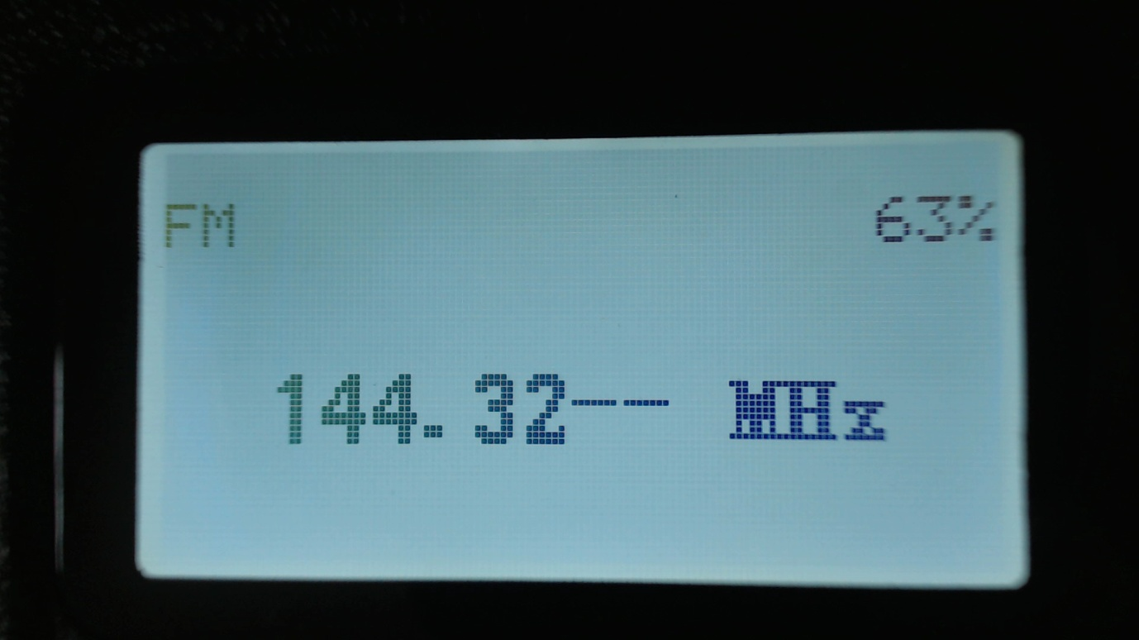

When all digits have been entered, the accept beep tones are played, and the display returns to the VFO screen.

If an invalid frequency is entered the error beep tones are played.

When entering a frequency:

Pressing the **Red** key cancels the entry

Pressing **Left Arrow** deletes the digits one by one.

To adjust the Tx frequency, independent of the Rx frequency.

Press the **Function (Blue)** button on the side of the radio, and the **Down arrow**.

This will change the currently selected frequency to the Tx frequency, and the arrow will move to the left of the “**T**” instead of the “**R**”

To change the Rx frequency again, press **Function + Up arrow**.

When the Tx frequency is changed, the Rx frequency will not be changed.

Use this method to set different Tx and Rx frequencies e.g. this can be useful for satellite operation as it allows Cross Band operation as well as split frequency simplex operation on the same band.

**Note**

If different Tx and Rx frequencies are set, and the currently selected input is set to Rx. Changing the Rx frequency will also change the Tx frequency, and the difference between the Rx and Tx frequency will be maintained if possible.

The only case where the frequency difference will not be maintained is if the Tx frequency goes outside of the range of frequencies supported by the radio hardware.

# Transmitting

During transmission the Talk Timer, either counts up or down depending on whether the channel has a timeout defined.

If a timeout is defined in the CPS, or adjusted in the Channel Details screen, the Talk Timer will count down and when the timeout period is reached a beep will play and the Tx will stop.

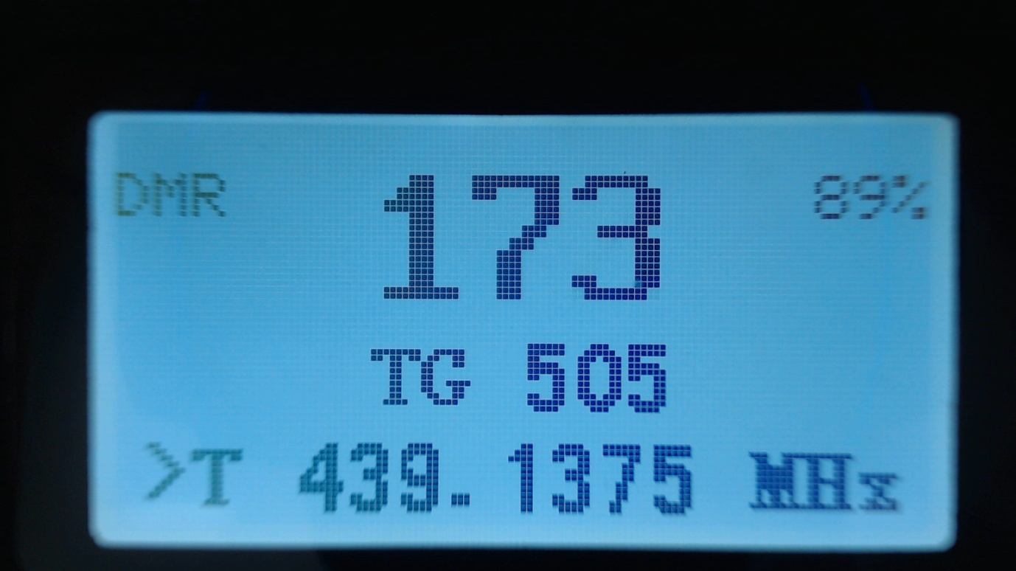

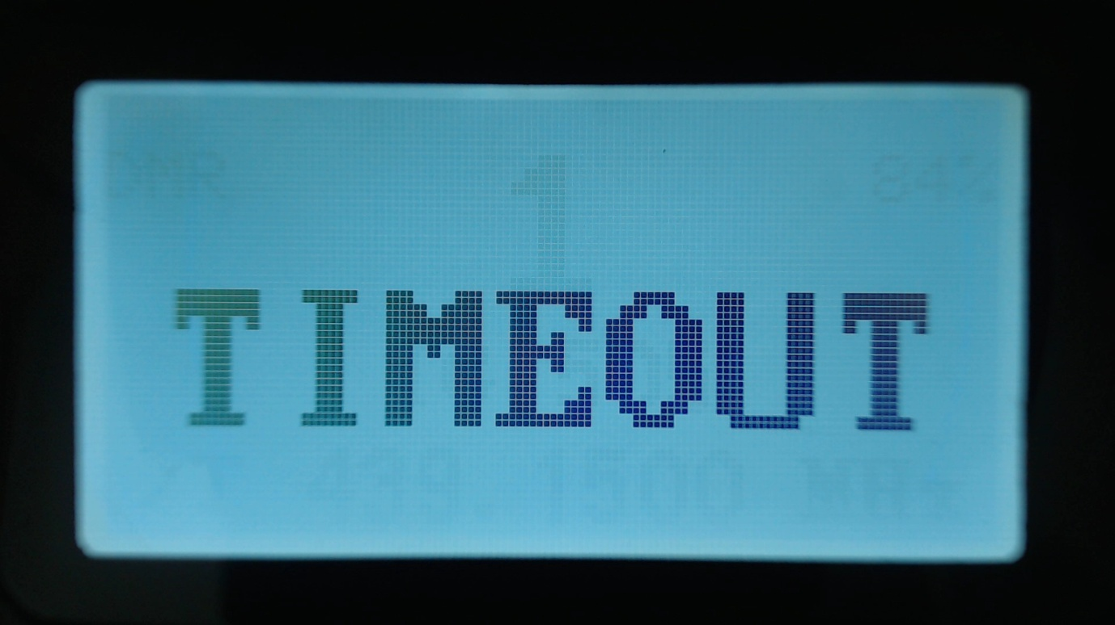

# A close up of text on a white background Description automatically generatedThe control keys and buttons

**The blue coloured button on the side of the radio is used as a “function” key.**

# The Menu System

Pressing the **GREEN** key enters the menu system, press again to enter a menu subsection or to exit the menu.

Press the **RED** key to step back one level or to exit the menu system.

The **UP** and **DOWN** arrow keys step up and down through the various pages of the menu system.

The **LEFT** and **RIGHT** arrow keys will change the individual items in the menu system where they are changeable.

The **BLUE** button on the side of the radio, known as SK2, is used as a “Function”. Various features are accessed by holding the “function” key when pressing a button on the keypad.

# Main Menu

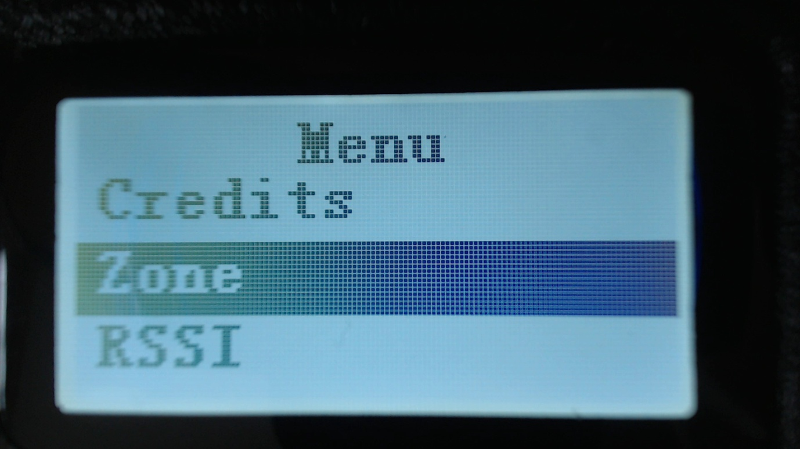

## Zone

This menu is used to select which groups of channels, called a Zone, is used in the Channel screen, and operates in the same way as the official Radioddity firmware, except with one addition.

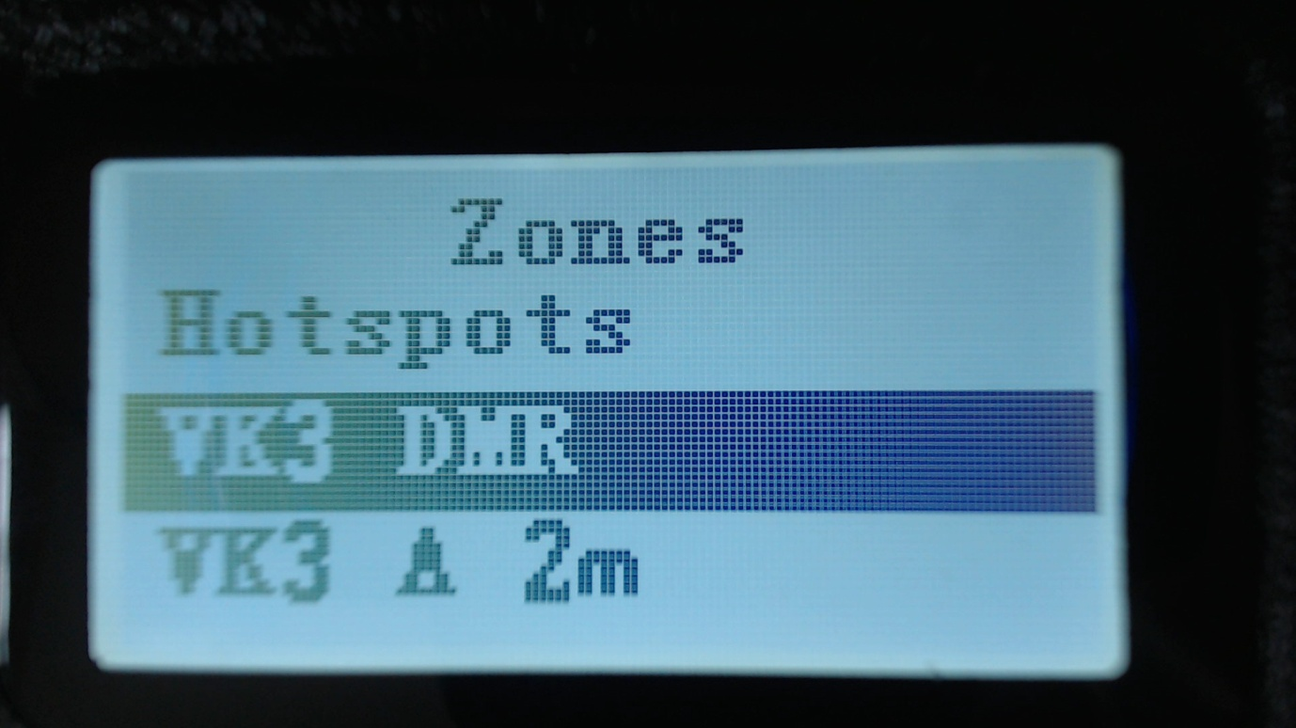

In addition to the Zones that are defined in the CPS and uploaded to the GD-77 using the Community CPS. The firmware creates a special Zone called all Channels

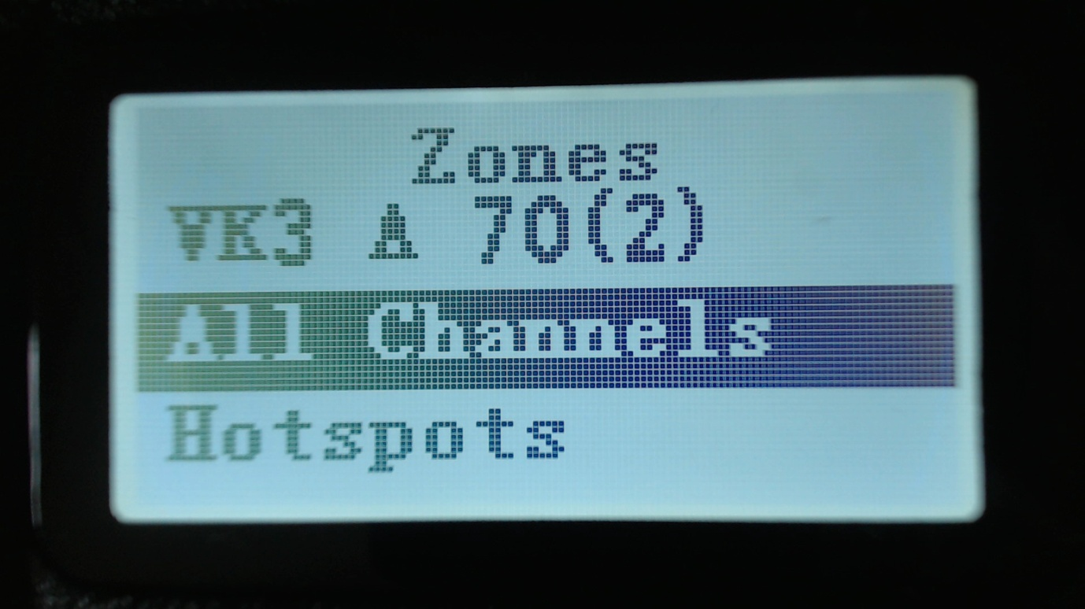

When the All Channels zone is selected, the Channel screen displays the channel number instead of the zone name e.g. CH 1

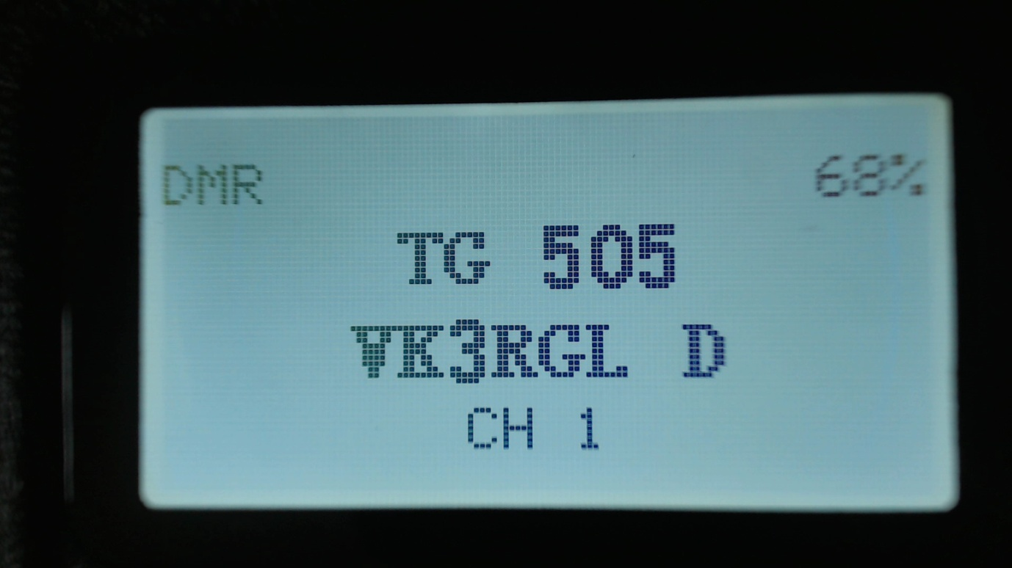

Pressing the **Up** and **Down** arrows will cycle though all channels in all zones

Pressing any of the number keys on the keypad, enters ‘Goto channel number mode’

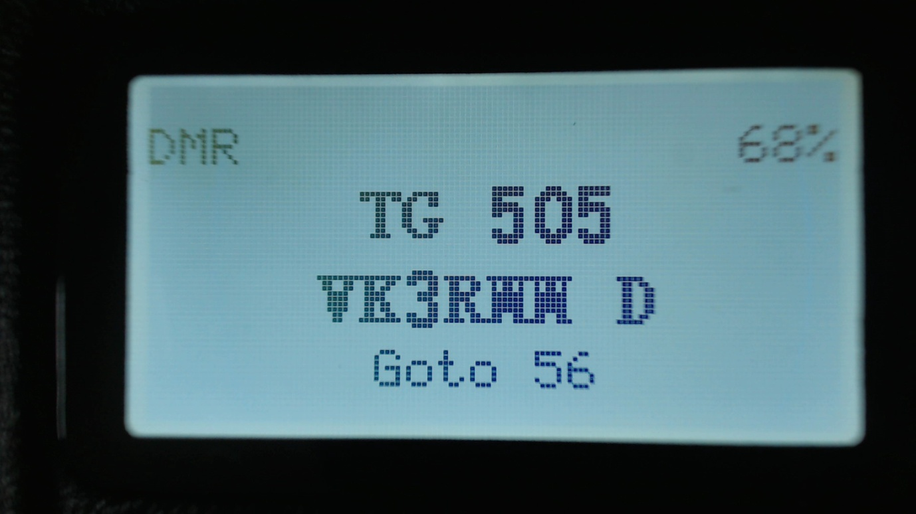

In this mode, you can enter multiple digits and then press the **Green** key to confirm, or the **Red** key to go cancel.

## RSSI

Displays a signal strength indicator showing the numerical RSSI value in dBm, along with an S-Unit bar graph.

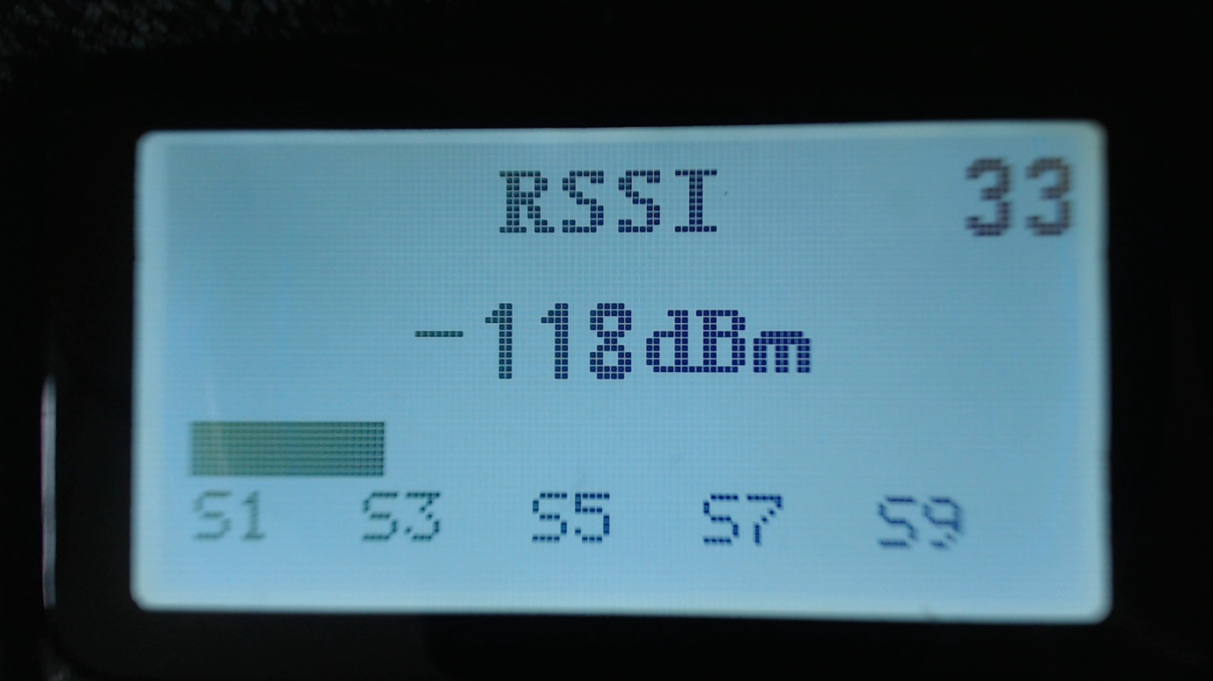

Notes

Both RSSI and S meter are not calibrated and will vary somewhat between different radios in their accuracy

DMR signals by their nature, because they are pulse transmissions will not give accurate RSSI values.

The number in the top right of the display is for debugging purposes and is the number reported by the receiver hardware.

## Battery

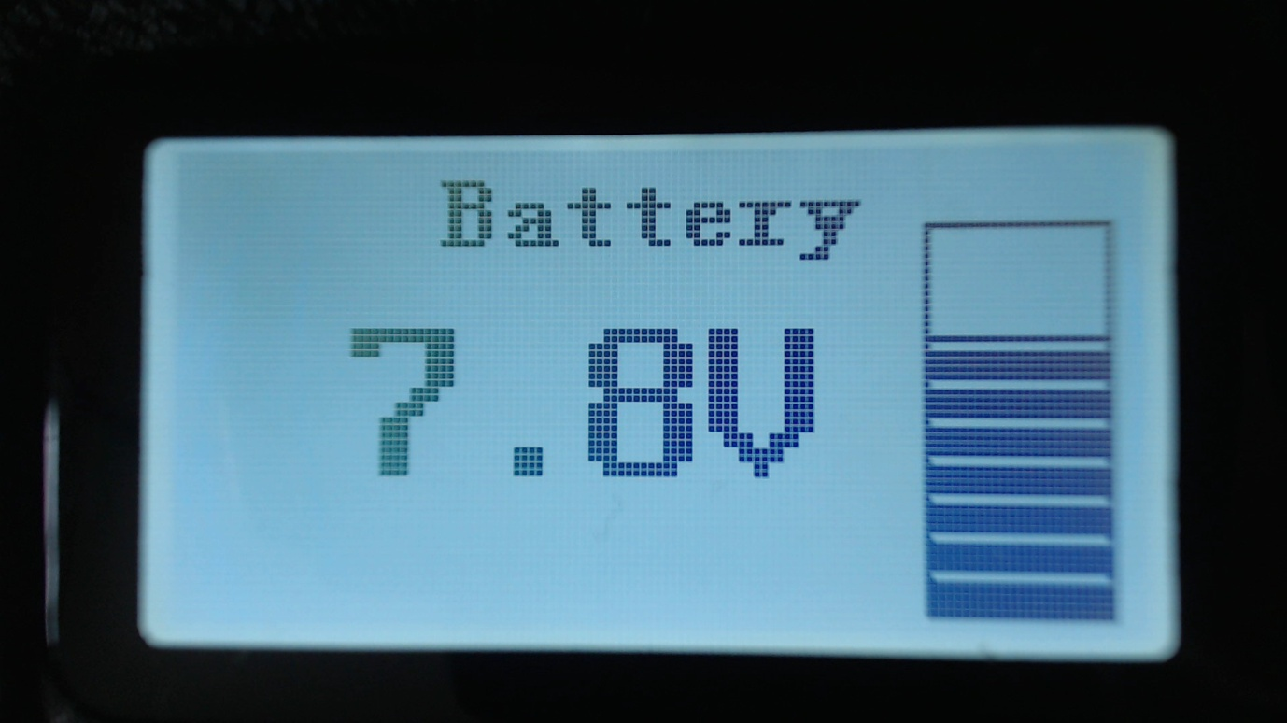

Displays the current battery voltage.

## Last Heard

Displays a record of the last 16 DMR stations that the radio has received.

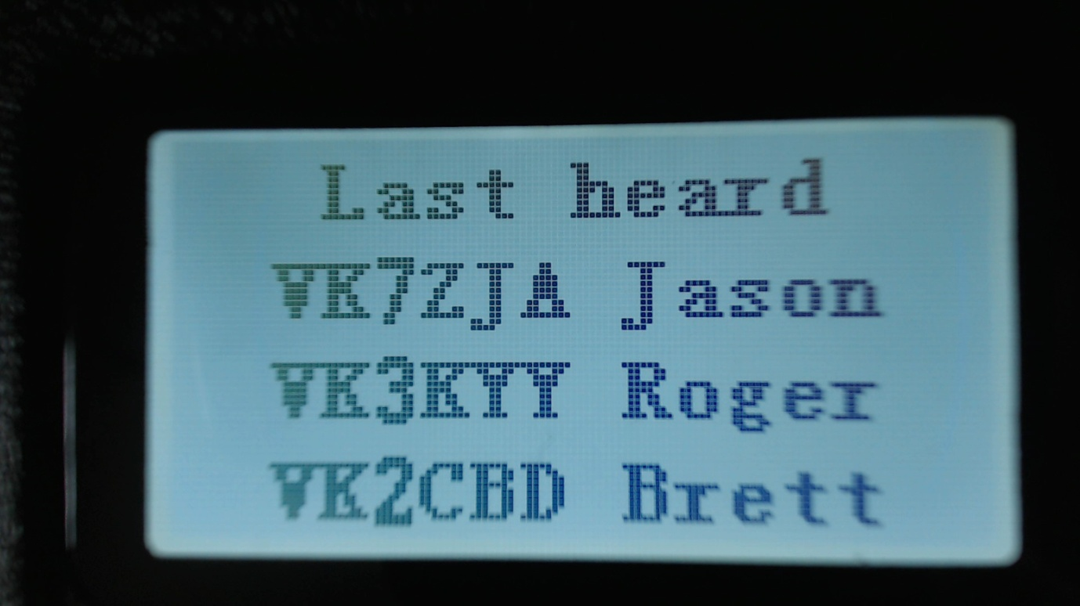

Pressing the Up and Down arrows cycles through the list to show stations which have been heard from time go.

## Firmware Info

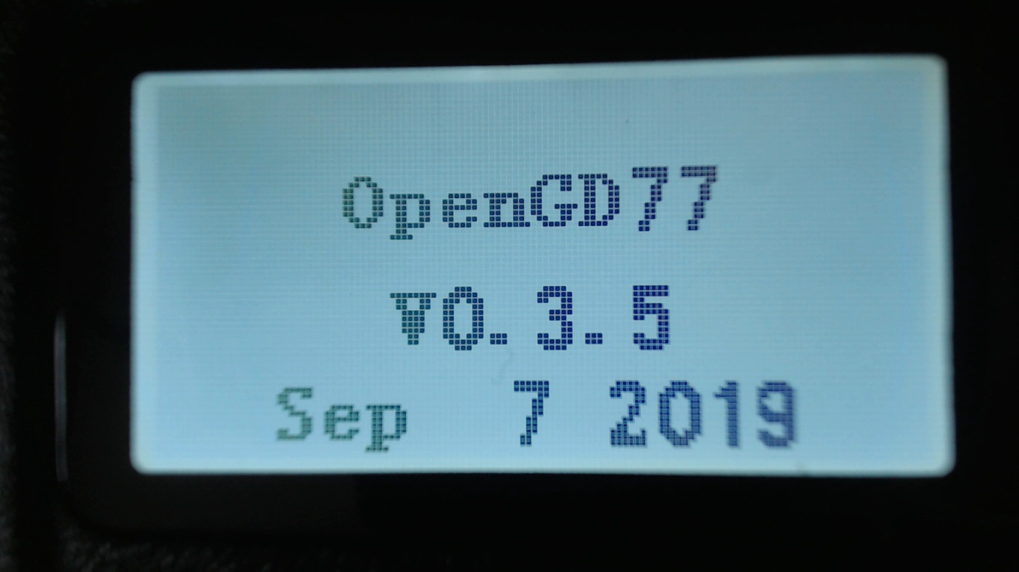

Displays the master firmware version number and the compile date.   
  
The compile date supersedes the master firmware version number, and is the best indication of the firmware version.

## Utilities

This menu controls various settings specific to the OpenGD77 firmware

**Beep volume**

This controls the volume of the beep and other tones, and can be set from 100% to 10%

**Power**

Currently the power control is in PA Drive units, rather than Watts. However in the future power setting will be a selection probably 0.25W, 0.5W, 1W,2W,3W,4W,5W.

The default power setting is 1600, which is approximately 1W.

Setting of around 3200 should give around 5W, however this will vary depending on whether the radio is transmitting on VHF or UHF and which end of the UHF band is being used.

**SQ**Turns the FM squelch on and off (default ON). Note. This has been partially superseded by the Squelch control in FM mode on both the VFO and Channel screens

**Timeout beep**

This setting controls whether the radio emits timeout warning beeps during transmission when the timeout is about to expire and transmission will be terminated.

**Fact Reset**Resets the radio to default settings, and reads the CPS VFO A values from the codeplug into the VFO screen.

**Calibration**Turns ON/OFF the calibration function (default OFF).

Some radios seem to have invalid calibration data, possibly because the official firmware has corrupted the calibration parameters in the Flash memory.

If the radio does not seem to transmit or receive correctly. Try disabling the calibration and rebooting the radio, as the nominal calibration parameters used by the OpenGD77 firmware normally work almost as well as correct calibration data.

**Band Limits**Turns ON/Off the transmit band limit function that prevent transmission outside of the Amateur Radio bands. (default ON).

## Display Options

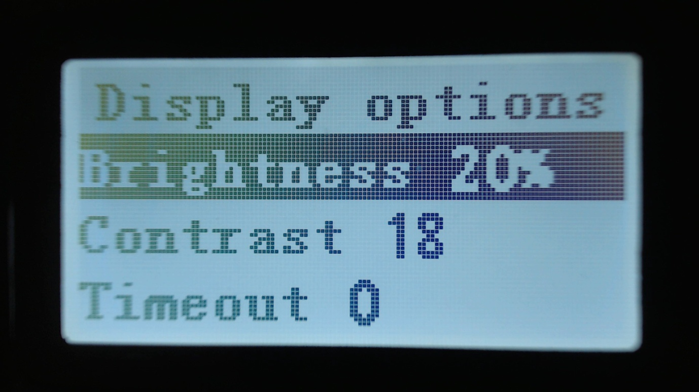

**Brightness**

The OpenGD77 firmware allows the display backlight brightness to be controlled from 100% to 0%, in 10% steps between 10% and 100% and below 10% the brightness is controlled in 1% steps.

The default backlight brightness (default 100%).

Use the Right and Left arrow keys to adjust the brightness.

**Contrast**

The OpenGD77 firmware allows the display contrast to be controlled.

The values are the number sent to the LCD panel controller, with a usable range from 12 to 30. Higher values result in more contrast, but also increase the darkness of the background.

The Official firmware uses a value of 12, however this is did not appear to be the optimum value, so the OpenGD77 firmware uses 18 as the default.

**Timeout**

Sets the time before the display backlight is extinguished (default 5 seconds).

Setting this value to zero prevents the backlight from turning off at all.

## Channel Details

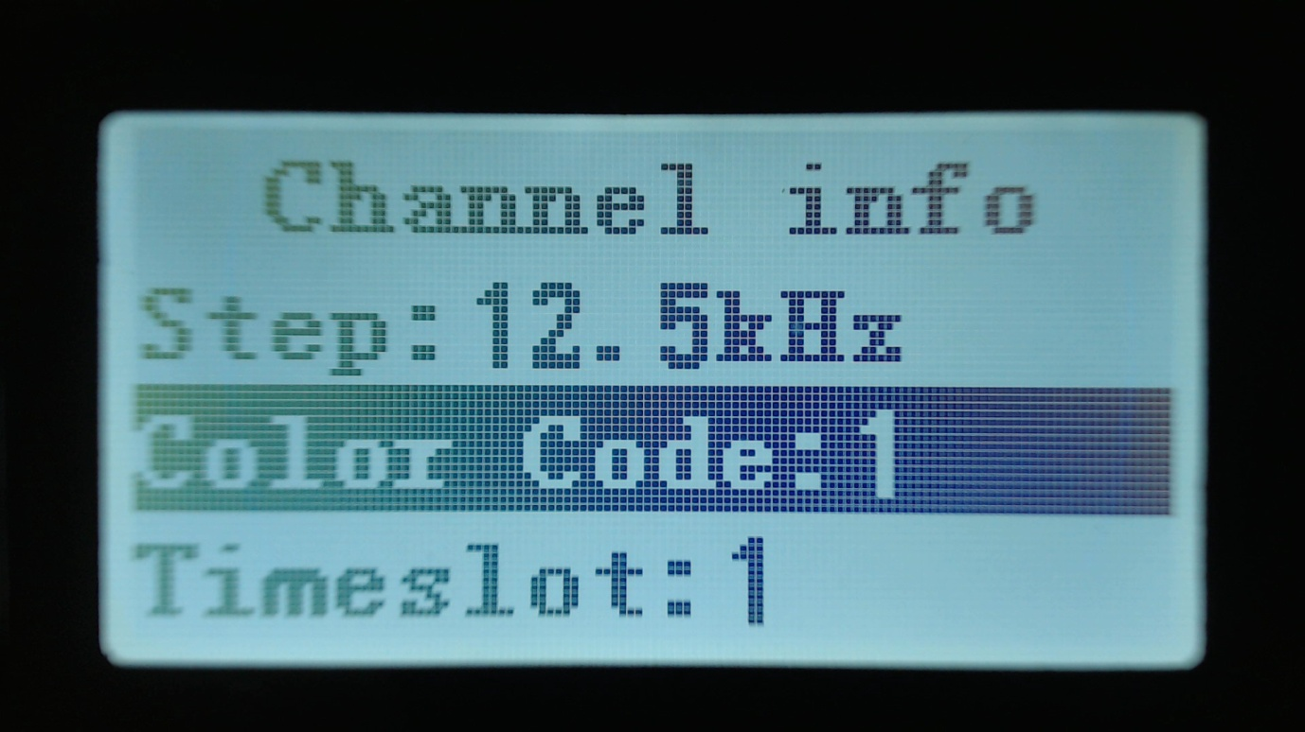

**Step**Selects the VFO/Channel frequency step size.

**Color Code**

Sets the color code when the VFO/Channel is set to DMR

**Timeslot**

Selects DMR Timeslot 1 or 2 when the VFO/Channel is set to DMR.

**Tx CTCSS**

Sets the transmit CTCSS tone when the VFO/Channel is set to FM

**RX CTCSS**

Sets the receive CTCSS tone when the VFO/Channel is set to FM

**Bandwidth**

Sets the Rx and Tx bandwidth in FM mode to either 25Khz or 12.5Khz

**Note.**

In the future other settings related to the Channel will also be controllable via this screen.

## Credits

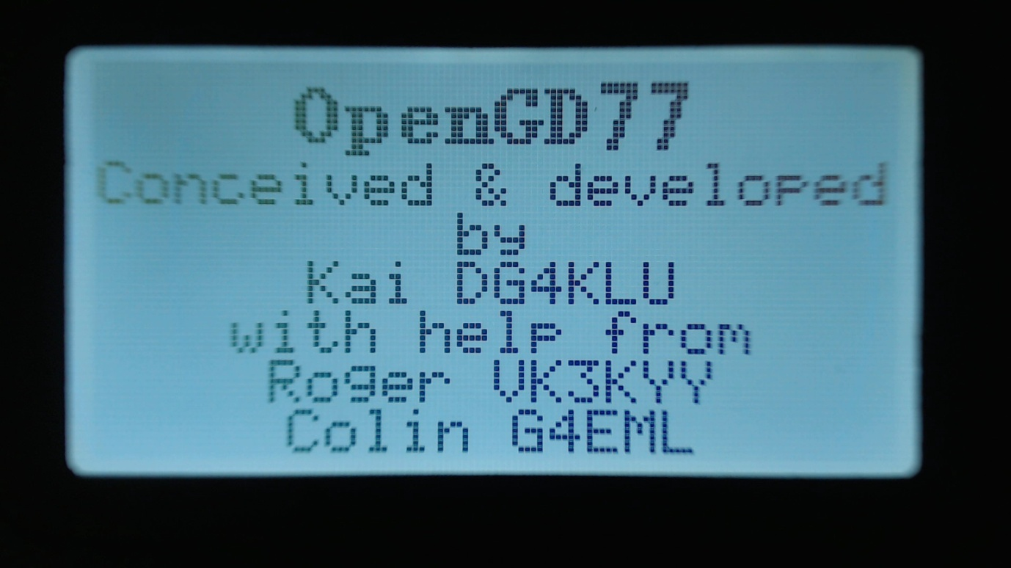

Details of the creators of OpenGD77 firmware.

If other developers contribute to the development effort they will be added to this screen, and the addition details will be viewed by pressing the **Down Arrow** to scroll the text

# Making and receiving DMR Private Calls

## To make a Private Call

* In DMR mode, either in the VFO or the Channel screen...
* Press the # key twice to enter the Private Call DMR ID
* The top of the screen will now show “PC entry”
* Enter the station’s DMR ID e.g. 5053238
* Press the Green menu key to conform, or the Red menu key to exit.
* Note.
* If you make a mistake when entering the number, press the **Left arrow** key to erase the digits one by one.
* If the PC ID you entered is in the DMR ID database, you had previously uploaded to the radio, the stations Callsign and name will now be displayed on the screen.
* If the ID is not in the DMR ID database, the text “ID: “ followed by the number will be displayed

**The radio is now in Private call mode.**

To return to normal Talkgroup operation, there are 3 methods

1. Press **Function + Red** menu key
2. Press the **Left or Right** arrow key which will load the next TG in the Rx Group list assigned to the VFO or the Channel
3. Press the **Hash (#)** key, then enter a TG number and press the **Green** menu key.

**Note**

When in Private Call mode, changing to from the VFO mode the Channel mode and vice versa, via the Red menu key will not change go back to TalkGroup mode

## To Receive a Private Call

On receipt of a private call, the radio will display this screen

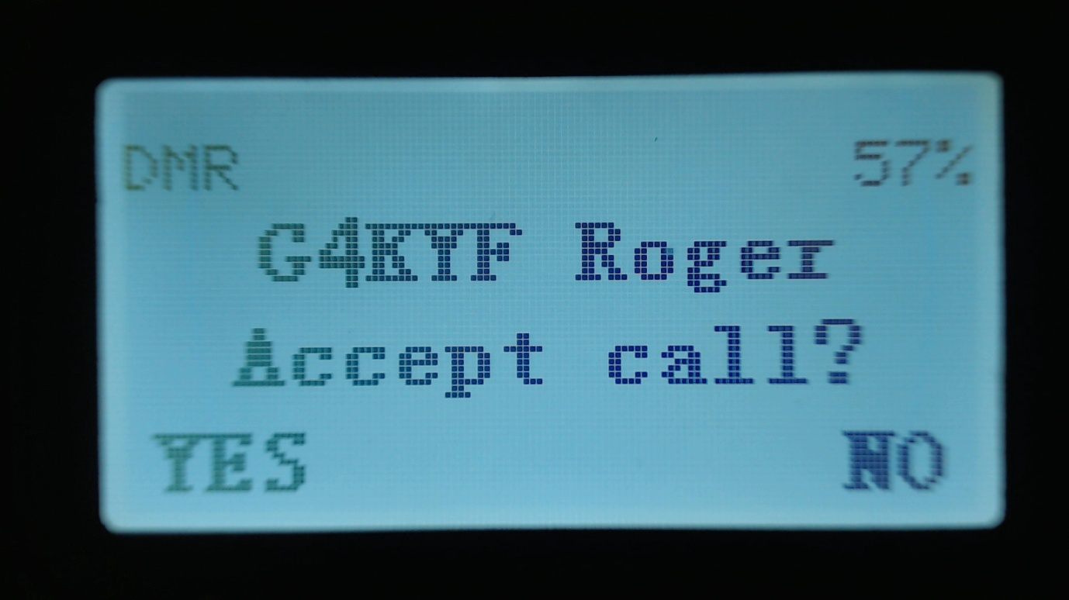

With the callers Callsign and Name (or ID) displayed on the above this text on the display.

To Accept the call, and configure the radio to return the Private call back to the calling station, Press the **Green** menu button, for YES. Otherwise either press the **Red** menu key, for No, or ignore the prompt and continue using the radio as normal.

If you accept the Private Call, the radio will be switched into Private Call mode, ready for transmission. So that the callers ID or name is show e.g.

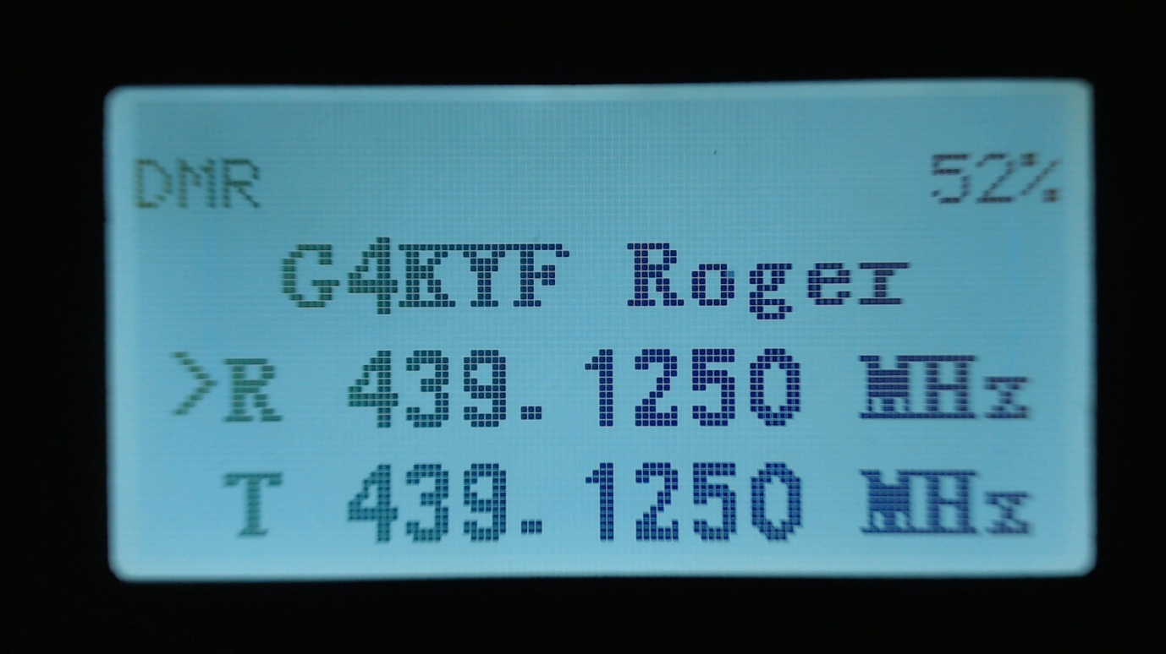

Once the private call is complete, you can return to the Talkgroup you were on prior to accepting the Private Call, by pressing **Function + Red** menu key. (or by any of the methods described in the section on making a Private Call)

# Programming Channels and Talkgroups for use with OpenGD77.

**NOTE**: You cannot use the standard Radioddity CPS to write to a GD-77 flashed with the OpenGD77 firmware. If you wish to use the Radioddity CPS the radio will need to run the official Radioddity firmware. Once the code plug has been written to the GD-77 you can then flash the OpenGD77 firmware to the radio and it will then read and operate with the code plug written to it with the standard firmware and CPS software.

As an alternative to the Radioddity CPS you can use the latest version of the “Community CPS” by Roger Clark that includes support for OpenGD77. Please see the next section for information specific to the Community CPS. The information in the rest of this section is applicable to both the standard Radioddity CPS and the Community CPS.

## OVERVIEW

With OpenGD77, unlike most commercial DMR radios it is not necessary to create multiple channels to use the same frequency with many different transmit Talkgroups.

In DMR mode when using either the VFO or the Zones and Channels, you can use the LEFT/RIGHT arrow keys to scroll through and select any of the Talkgroups in the Rx Group list assigned to the current channel, or to VFO A

When programming the radio using the CPS first add all the Talkgroups that you think you may wish to use into the Digital Contacts list.

Please download the latest GD77 Community CPS from here:

<https://github.com/rogerclarkmelbourne/radioddity_gd-77_cps/raw/master/installer/RadioddityGD77CPS31XCommunityEditionInstaller.exe>

Next create one or more “RX Group Lists” and populate each with the sets of the Talkgroups that you will want to use with different channels. You can have the same Talkgroups in many RX Group Lists.

Now setup the channels. Enter the frequencies, slot and colour code as normal for a DMR channel.

Note. Currently the OpenGD77 firmware does not use the “Contact” eg. Shown as TG9 below. Instead it uses the TG’s in the Rx Group list.   
However we advise all users to set the “Contact” to the first channel in the Rx Group list assigned to the channel

Next select the RX Group List that you wish to use for the channel.

Currently the OpenGD77 firmware does not use the Rx Group list to filter the incoming DMR signal. It is in “Digital Monitor Mode” (aka promiscuous mode) all the time.

However in the future the firmware will optionally allow filtering so that the radio only accepts stations transmitting on one of the TG’s in the Rx Group List

Finally save your codeplug to your computer before writing the code plug to the radio using either the standard Radioddity CPS to programme the radio before flashing it to OpenGD77 or if you are using the special OpenGD77 compatible version of the “Community CPS”, (as detailed in the next section) you can write the code plug directly to an already flashed OpenGD77 radio.

# USING THE COMMUNITY CPS TO PROGAMME A GD-77

Initial support for the OpenGD77 has now been included in a special version of the Community CPS by Roger Clark, which can be downloaded from here:

<https://github.com/rogerclarkmelbourne/radioddity_gd-77_cps/raw/master/installer/RadioddityGD77CPS31XCommunityEditionInstaller.exe>

This version also still supports the official firmware, using the normal Read and Write buttons on the main screen.

### New Driver Installation

To use the Community CPS with an OpenGD77 radio, you will need to install a driver, because the OpenGD77 operates as Serial USB device.

The 2 files that are needed to install the driver are here

<https://github.com/hamdv/OpenGD77/tree/master/OpenGD77CommDriver>

 Once the driver is installed, the Windows device manager should show the “OpenGD77” in the “ports” section.

### OpenGD77 Menu

 In the CPS , there is a new menu item under the Extras menu for OpenGD77 Support, which opens this window

 From here you can backup, the internal 64k EEPOM and the 1 mega byte Flash chip, as well as Reading and Writing the codeplug.

### Backup Before You Do Anything Else!

Before writing a codeplug to the radio, you should backup both the EEPROM and Flash chip, and save the files somewhere safe, in case something goes wrong in the future and you need to restore the data.

### Reading and Writing Your Codeplug

To read the codeplug, press the “Read codeplug” button, wait for all 3 data sections to download, and then close the OpenGD77 Support window. To write a codeplug press the “Write codeplug” button.

### Writing DMR ID’s

DMR ID support has also been added, in the DMR ID window, where there is an extra button at the bottom, labeled “Write to OpenGD77”

